Union and intersection of sets: The union $(∪)$of 2 sets includes all the elements of the sets. The intersection $\left(∩\right)$ of 2 sets includes the elements that are common in both sets.
Ex. $A=\left\{-2,4,7,12\right\}$ and $B=\left\{5,7,10\right\}$ $A∪B=\left\{-2,4,5,7,10,12\right\}$ and $A∩B=\left\{7\right\}$
Ex. $A=\left\{even \#s\right\}$ and $B=\left\{odd \#s\right\}$ $A∩B= ∅$

You try:
Find the union and intersection: $A=\left\{-3,-1,0,9\right\}$ and $B=\left\{-4,-1,0,4\right\}$

Find the intersection: $A=\left\{\#s divisible by 3\right\}$ and $B=\left\{-8,-6,-1,9,12\right\}$

Relation: A set of ordered pairs.
Domain and Range: The domain includes all the x values of the relation. The range contains all the y values.
Given a graph, to find the domain, look to the far left and right of the graph. To find the range, look to the bottom and the top of the graph.
Notation: If the graph has an arrow at the end, use the $-∞$ or $∞$ symbol. If the graph has a closed dot, use a bracket . If it is an open circle or an arrow, use a parenthesis.
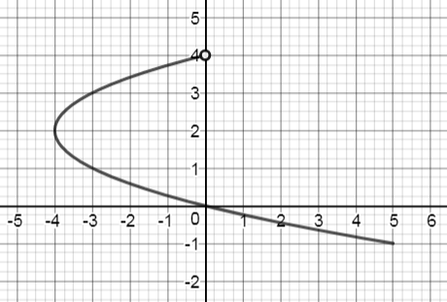
Function: A set in which each element of the domain is matched with exactly one element of the range (all x values must be different in order to be a function). In a graph, it is a function if you can draw a vertical line anywhere and only hit the graph once.
X | Y
-3 | 5
4 | -2
4 | 7
7 | 8
Ex.

Is this a function?
No (fails the vertical line test)
Domain: $\left[-4,∞) \right.$
Range: $\left(-∞,4\right)$
Is this a function?
No (x values repeat)
Domain: $\left\{-3,4,7\right\}$
Range: $\left\{-2,5,7,8\right\}$

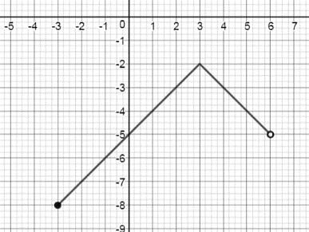
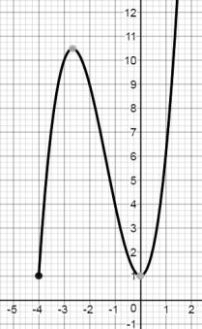
You try:
Is this a function?

Domain:

Range:
Is this a function?

Domain:

Range:

Math with functions: Given functions $a(x)=5x$ and $b\left(x\right)=2x+1$
$\left(a+b\right)\left(x\right)$ asks you to add the 2 functions $=5x+\left(2x+1\right)=5x+2x+1=7x+1$
$\left(a+b\right)\left(3\right)$ wants you to plug 3 into that expression, so $7\left(3\right)+1=21+1=22$
$$\left(a-b\right)\left(x\right)=5x-\left(2x+1\right)=5x-2x-1=3x-1$$
$$\left(a-b\right)\left(-4\right)=3\left(-4\right)-1=-12-1=-13$$
$\left(b-a\right)\left(3\right)=\left(2x+1\right)-5x=2x+1-5x=-3x+1$ $→$ $-3\left(3\right)+1=-9+1=-8$
$$\left(a*b\right)\left(x\right)=5x\left(2x+1\right)=10x^{2}+5x$$
$$\left(a*b\right)\left(-2\right)=10{\left(-2\right)}^{2}+5\left(-2\right)=10\left(4\right)-10=40-10=30$$
$\left(a∘b\right)\left(x\right)$ ask you to plug the b equation into the a equation for x $=5\left(2x+1\right)=10x+5$
$$\left(a∘b\right)\left(5\right)=10\left(5\right)+5=50+5=55$$
$\left(b∘a\right)\left(x\right)$ ask you to plug the a equation into the b equation for x $=2\left(5x\right)+1=10x+1$
$$\left(b∘a\right)\left(-6\right)=10\left(-6\right)+1=-60+1=-59$$

You try: Given $c\left(x\right)=-3x d\left(x\right)=2x^{2} e\left(x\right)=4x-3$
$(e+c)(19)$ $(c-e)(2)$ $\left(c*e\right)(-1)$

$(d∘c)(-1)$ $(c∘e)(-6)$

Inverse: The inverse of a set of ordered pairs with domain of x and range of y has a domain of y and a range of x.
Ex. Given ordered pairs, flip the x and y Inverse of $(5,2)$ is $(2,5)$ Inverse of $(-3,8)$ is $\left(8,-3\right)$

Given a graph, find key points, flip the $(x,y)$ to $(y,x)$
Inverse
Original
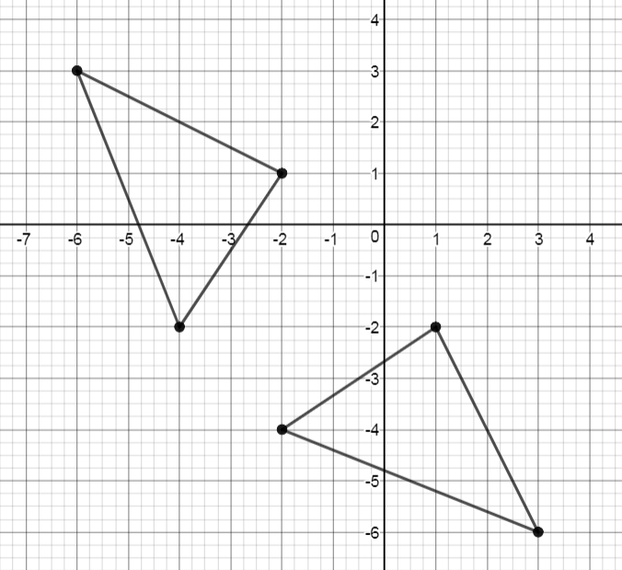
Original
X | Y
-6 | 3
-4 | -2
-2 | 1

Inverse
X | Y
3 | -6
-2 | -4
1 | -2

You try: Graph the inverse.
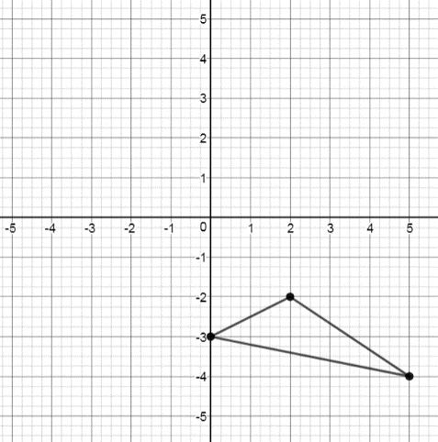
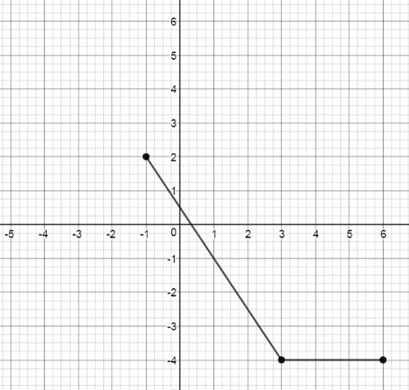

Finding the inverse of an equation: Flip the x and y, then re-solve for y.
Ex. $y=2x-7$ $y=x^{2}+2$ $y=\sqrt{x+4}-9$
$x=2y-7$ $x=y^{2}+2$ $x=\sqrt{y+4}-9$
$x+7=2y$ $x-2=y^{2}$ $x+9=\sqrt{y+4}$
$\frac{x+7}{2}=y$ $\sqrt{x-2}=y$ ${\left(x+9\right)}^{2}=y+4$
${\left(x+9\right)}^{2}-4=y$

You try: Find the inverse of the equation.
$y=3x+4$ $y=\frac{x}{5}-8$ $y=\frac{x+6}{7}$

$y={\left(x-3\right)}^{2}$ $y=\sqrt{x+11}-8$

