Graphing a Parabola $(y=ax^{2}+bx+c)$: First, find the vertex $(x,y)$.The x-value of the vertex can be found using the equation $x=-\frac{b}{2a}$. Plug that in to find y. Then choose more x-values to plug into the equation and find their y-values. Graph the ordered pairs.
Note: A parabola will reflect across the vertical line that contains the vertex.
Choose 2 x-values on one side of the vertex. Find the y-values and plot the ordered pairs.
Then plot the reflections of these ordered pairs across that midline.
Ex. Graph $y=x^{2}-8x+7$
Vertex: $x=-\frac{b}{2a}=\frac{8}{2\left(1\right)}=\frac{8}{2}=4$
$$y={\left(4\right)}^{2}-8\left(4\right)+7=16-32+7=-9$$
Vertex: $(4,-9)$
X | Y
2 | -5
3 | -8
4 | -9
5 | -8
6 | -5
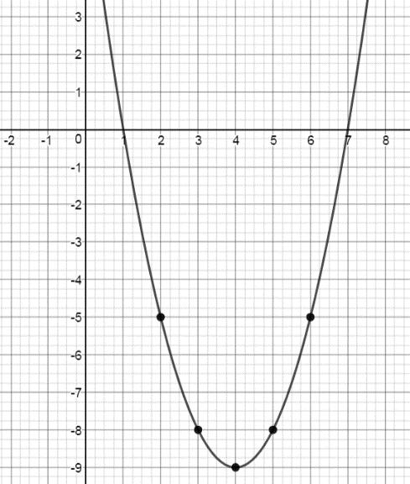
$$→ y={\left(2\right)}^{2}-8\left(2\right)+7=-5$$
$$→ y={\left(3\right)}^{2}-8\left(3\right)+7=-8$$

You try: Find the vertex and graph.
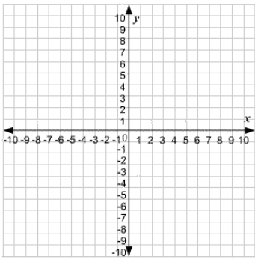
$y={4x}^{2}+16x+9$

Find the vertex and graph.
$$y=2x^{2}-12x+11$$

Solve (when factoring doesn’t work): Use the quadratic formula. $x=\frac{-b±\sqrt{b^{2}-4ac}}{2a}$
Ex. $y=x^{2}-6x-11$ $y=2x^{2}+10x+3$
$x=\frac{6±\sqrt{{(-6)}^{2}-4(1)(-11)}}{2(1)}$ $x=\frac{-10±\sqrt{{(10)}^{2}-4(2)(3)}}{2(2)}$
$x=\frac{6±\sqrt{36+44}}{2}=\frac{6±\sqrt{80}}{2}$ $x=\frac{-10±\sqrt{100-24}}{4}=\frac{-10±\sqrt{76}}{4}$
$x=\frac{6±4\sqrt{5}}{2} or 3±2\sqrt{5}$ $x=\frac{-10±2\sqrt{19}}{4} or \frac{-5±\sqrt{19}}{2}$

You try: $y=3x^{2}-10x+1$ $y=2x^{2}+4x-7$

Bonus: Quadratic Formula with imaginary roots Rule: $\sqrt{-1}=i$
Ex. $\sqrt{4}=2 so \sqrt{-4}=2i$ $\sqrt{-50}=\sqrt{-1*5*5*2}=5i\sqrt{2}$

You try: $\sqrt{-90}$ $\sqrt{-48}$

Solve.
Ex. $y=3x^{2}-4x+4$

$x=\frac{4±\sqrt{{\left(-4\right)}^{2}-4(3)(4)}}{2(3)}=\frac{4±\sqrt{16-48}}{6}=\frac{4±\sqrt{-32}}{6}=\frac{4±4i\sqrt{2}}{6} or \frac{2±2i\sqrt{2}}{3}$

You try: $y=2x^{2}+6x+7$

