Similar Triangles and Vertical Angles: For 2 triangles to be similar, they must have equal angle measures and proportionate sides. Vertical angles are the opposite angles formed from 2 intersecting lines. Vertical angles are congruent.
Ex. Given the 2 triangles and angle measures, determine if the triangles are similar.
$$180°-54°-68°=58°$$

$$180°-46°-34°=91°$$
$$91°$$
$$43°$$
$$43°$$
$$46°$$
$$68°$$
$$57°$$
$$54°$$
$$180°-43°-91°=46°$$

$$180°-57°-68°=55°$$

NO
YES

You try: Are the triangles similar?
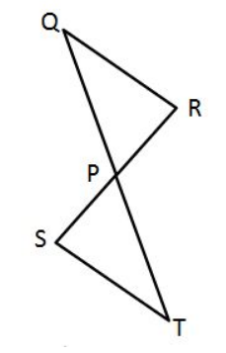
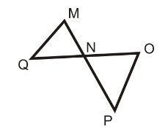
$$51°$$
$$39°$$
$$60°$$
$$50°$$
$$70°$$
$$40°$$
$$56°$$
$$80°$$
$$56°$$

$$82°$$

Ex. Find the missing angles given the figures. Reminder: if two angles make up a linear pair, the angles are supplementary (sum is $180°)$. The symbol $\sim$ means similar.
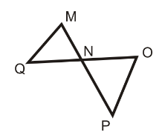
Given: $m∠MNQ=68°,$ $m∠QMN=70°,: m∠OPN=44°$
Find:
$m∠MQN=$ $180°-70°-68°=42°$
$m∠ONP=$ $68°$
$m∠NOP=$ $180°-68°-44°=68°$
$Is ∆MNQ\sim ∆ONP?$ NO

You try:
Given: $m∠BCA=61°,$ $m∠BAC=60°,: m∠EDC=59°$
Find:
$$m∠ABC=$$
$$m∠DCE=$$
$$m∠DEC=$$
$$Is ∆ABC\sim ∆EDC?$$

Pythagorean Theorem: In a right triangle with legs a and b and hypotenuse c, $a^{2}+b^{2}=c^{2}$
Ex. Find the missing side.
Given a right triangle where $a=4$ and $c=10$, find b
7
4
$$4^{2}+b^{2}={10}^{2}$$
$$16+b^{2}=100$$
$$b^{2}=84$$
$$b=\sqrt{84}=2\sqrt{21}$$
$$7^{2}+4^{2}=c^{2}$$
$$49+16=c^{2}$$
$$65=c^{2}$$
$$\sqrt{65}=c$$

You try: Find the missing side.
6
2
5
8

Given a right triangle with $b=8$ and $c=12$, find a.

