2-dimensions
Perimeter: The sum of all sides
Area: Square $A=s^{2}$ Rectangle or Parallelogram $A=b*h$ Triangle $A=\frac{1}{2}bh$ Circle $A=πr^{2}$
Circumference of a Circle $C=2πr or πd$ (leave all answers in terms of $π$)

Ex. Find the circumference and area of a circle with a diameter of 8 cm.
If $d=8$, then $r=4$ $A=π*4^{2}=16π cm^{2}$ $C=π*8=8π cm$

Ex. Find the perimeter and area of the following (assume all sides in cm):
Square Rectangle
$$P=9+4+9+4=26cm$$
$$A=9*4=36cm^{2}$$
$$P=5+5+5+5=20cm$$
$$A=5*5=25cm^{2}$$
5
4
9

Triangle Parallelogram
$$P=6+4+6+4=20cm$$
$$A=6*3=18cm^{2}$$
$$P=5+8+6=19cm$$
$$A=\frac{1}{2}(8)(3)=12cm^{2}$$
6
4
3
3
5
6
8

Ex. Find the value given the dimensions of the rectangle.
Ex. 2. $P=120m$ $AD=x+5$ $AB=x$ Find $BC$.
$\left(x+5\right)+x+\left(x+5\right)+x=110$ $4x+10=110$ $4x=100$ $x=25$ $BC=x+5=25+5=30m$
Ex. 1. $P=100m$ $BC=15m$ Find $AB$.
$15+15+x+x=100$ $30+2x=100$ $2x=70$ $x=AB=35m$

3-dimensions
Surface Area: Sum of the areas of all sides
Volume: Rectangular Prism $V=l*w*h$ Cylinder $V=πr^{2}h$ Cone $\frac{1}{3}πr^{2}h$

Ex. Find the surface area and volume of the rectangular prisms (assume all sides in cm).
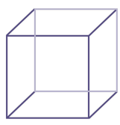
3
2
4
5
Cube Rectangular Prism
Front/Back $A=4*3=12cm^{2}$ Top/Bottom $A=4*2=8cm^{2}$
Left/Right $A=2*3=6cm^{2}$ $SA=12+12+8+8+6+6=52cm^{2}$
$$V=4*2*3=24cm^{3}$$
Each side has $A=5*5=25cm^{2}$
$$SA=6*25cm^{2}=150cm^{2}$$
$$V=5*5*5=125cm^{3}$$

Ex. Find the volume. Leave answers in terms of $π$.
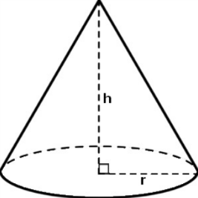
Cylinder Cone
$$d=6cm$$
$$h=14cm$$
$$h=7cm$$
$$r=2cm$$

$V=π*2^{2}*7=4*7*π=28π cm^{3}$ If $d=6cm, then r=3cm$
$V=\frac{1}{3}*π*3^{2}*6=\frac{1}{3}*9*6*π=18π cm^{3}$

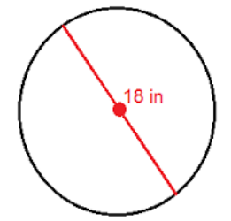
You try:
- Find the area and circumference of the circle.

Find the perimeter and area of the following (assume all sides in cm).
- Rectangle with base of $11$ and a height of $6$.

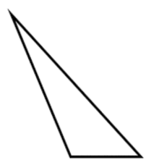
10
13
15
9
- Triangle

- Parallelogram
5
9
4

For 5-7, find the side length of the rectangle given the dimensions.
- $P=46m, AB=16m$ Find $BC$

- $P=84m, AB=4x-3, BC=x$ Find $CD$

- $P=104m, CD=4x+1, BC=x-4$ Find $AD$

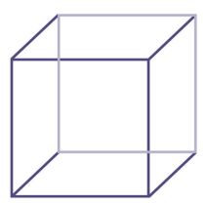
Find the surface area and volume.
- Cube with side length of $2cm$.

- Rectangular prism with $l=10m, w=4m,h=6m$

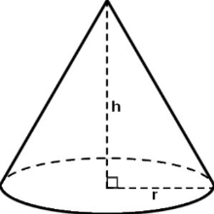
Find the volume. Leave answers in terms of $π$.
- Cone with $h=30cm, r=11cm$

- Cylinder with $h=28mm, d=20mm$

