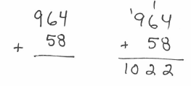
Addition: Put the larger number on top. Start in the ones place, add, and carry to the tens place if necessary.
Example: $58+964$

You try: $943+1578$ $7034+675$

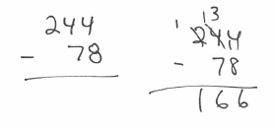
Subtraction: If the number on top is smaller than the number below it, borrow from the next column.
Example: $244-78$

You try: $865-272$ $500-181$ $7024-5648$

Multiplication: 4 methods to choose from
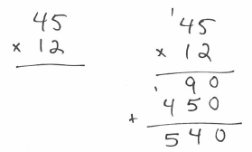
Example: $45*12$
Method 1: Old School

Practice this method: $31*25$ $63*42$ $56*81$

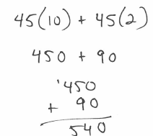
Method 2: Break up the 12 $45*12$

Practice this method: $31*25$ $63*42$ $56*81$

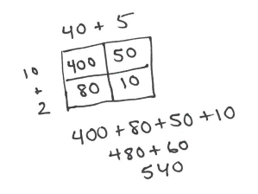
Method 3: Punnett Square $45*12$

Practice this method: $31*25$ $63*42$ $56*81$

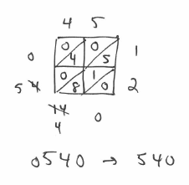
Method 4: Lattice $45*12$

Practice this method: $31*25$ $63*42$ $56*81$

You try (using the method of your choice): $14*43$ $34*26$

Try using all 4 methods: $57*62$

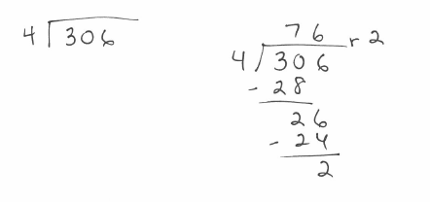
Division: Long Division with Remainders
Example: $306÷4$

You try: $180÷7$ $360÷15$ $500÷14$

