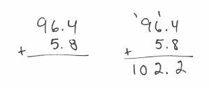
Addition: Put the larger number on top. Line up the decimal points. Start in the ones place, add, and carry to the tens place if necessary. If there is a missing decimal place, put a zero there.
Example: $5.8+96.4$

You try: $94.38+157.8$ $750.34+67.5$

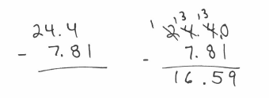
Subtraction: If the number on top is smaller than the number below it, borrow from the next column. If there is a missing decimal place, put a zero there.
Example: $24.4-7.81$

You try: $86.5-2.72$ $500.6-1.81$ $7.02-5.648$

Multiplication: Use Method 1 or 4 from your first lesson. If using Method 1, put the number with the most digits on top. With either method, ignore the decimal places until the end. Count the total number of places AFTER the decimal point and move that number of decimal places to the left for your answer.
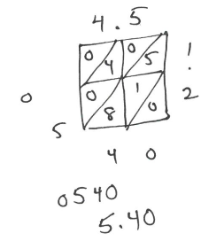
Example: $4.5*1.2$
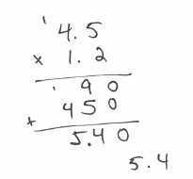
Method 1: Method 4:

You try: $3.1*2.53$ $63.5*4.2$

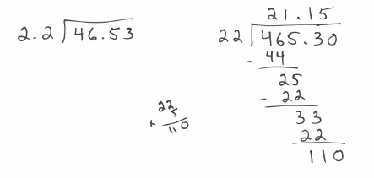
Division: Long Division with no remainders. The divisor cannot have a decimal, so move the decimal place to the right until it’s a whole number. Move the decimal place in the dividend the same number of spots. The decimal point in your answer will line up with the dividend’s decimal. You need to continue the dividing process until you do not have a remainder (keep adding zero to the dividend).
Example: $46.53÷2.2$

You try: $7.452÷.23$ $11.75÷9.4$ $13.704÷.3$

