Review:
Reduce a fraction: Divide the numerator and denominator by the same number until they can no longer be divided evenly.
$\frac{200}{450}$ $→$ $\frac{200}{450}÷\frac{10}{10}=\frac{20}{45}÷\frac{5}{5}=\frac{4}{9}$

Improper Fraction to a Mixed Number: Figure out how many times the denominator divides evenly into the numerator. That is the whole number. Write the remainder (left over) over the denominator.
$\frac{29}{6}$ $→$ 6 divides into 29 four times, making 24. $29-24=5$, so that’s what’s left. $Ans: 4\frac{5}{6}$

Mixed number to an Improper Fraction: Multiply the denominator by the whole number. Add that to the numerator, and place it over the denominator.
$5\frac{7}{8}$ $→$ $8*5=40$ $→$ $40+7=47$ $→$ $Ans:$ $\frac{47}{8}$

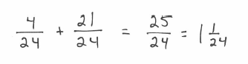
Adding and Subtracting: If you have common denominators, just add or subtract the numerator, put over the denominator, and reduce as necessary. If they don’t have common denominators, multiply the denominators (and numerators) by a number so that you can achieve common denominators first. Then add/subtract.
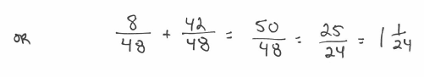
Example: $\frac{1}{6}+\frac{7}{8}$

You try: $\frac{9}{8}-\frac{3}{4}$ $\frac{3}{5}+\frac{5}{6}$ $\frac{7}{4}+\frac{2}{3}$

Multiplying: You do NOT need common denominators. Simply multiply numerators and multiply denominators. Reduce your answer as necessary.
Example: $\frac{3}{4}*\frac{2}{9}$ $→$ $\frac{6}{36}=\frac{1}{6}$

You try: $\frac{7}{2}*\frac{5}{8}$ $\frac{9}{10}*\frac{5}{3}$ $3\frac{1}{2}*2\frac{3}{4}$

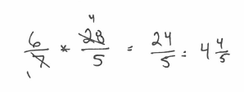
Option: Simplify (cancel like terms) as you go to ensure smaller numbers in your answer.
Example: $\frac{6}{7}*\frac{28}{5}$

You try: $\frac{8}{5}*\frac{10}{4}$ $\frac{3}{14}*\frac{28}{33}$ $8*\frac{3}{10}$

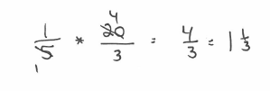
Dividing: Dividing is the same as multiplying by the reciprocal. Keep the first fraction the same. Change the problem from division to multiplication. Then flip the 2nd fraction (the reciprocal). Multiply the fractions.
Example: $\frac{1}{5}÷\frac{3}{20}$

You try: $\frac{7}{10}÷\frac{21}{2}$ $\frac{15}{16}÷\frac{5}{8}$ $\frac{4}{3}÷2$

