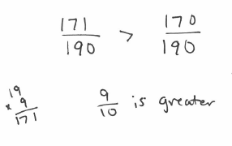
Comparing Fractions: Make common denominators. The fraction with the larger numerator is the greater fraction. Recall $>$ means greater than and $<$ means less than (looks like an L!).
Example: Place the correct symbol between the fractions $\frac{9}{10}$ $\frac{17}{19}$

You try: $\frac{14}{11}$ $\frac{7}{5}$ $\frac{12}{13}$ $\frac{25}{26}$

Put these fractions in order from smallest to largest: $\frac{5}{6},\frac{-1}{5},\frac{3}{4},\frac{-13}{60},\frac{11}{15}$

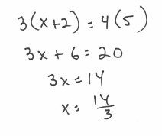
Proportions: Set cross products equal to each other, then solve.
Example: $\frac{x+2}{5}=\frac{4}{3}$

You try: $\frac{16}{5}=\frac{2}{x}$ $\frac{5}{2}=\frac{x-1}{6}$ $\frac{x+5}{2}=\frac{x-4}{3}$

Percent to a fraction: A percent is defined as a number out of 100, so write the fraction and reduce. If the percent is already a decimal, move the decimal places first so that the numerator is a whole number.
Example: $3.5\%$ $→$ $\frac{3.5}{100}=\frac{35}{1000}=\frac{7}{200}$

You try: $125\%$ $16\%$ $5.5\%$

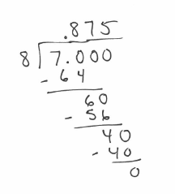
Fraction to a percent: Use long division. Add a decimal point and as many zeroes as needed in order to divide.
Example: $\frac{7}{8}$

You try: $\frac{4}{5}$ $\frac{13}{4}$ $\frac{7}{11}$

Percent of a number: Change the percent to a decimal (move the decimal 2 places to the left), then multiply.
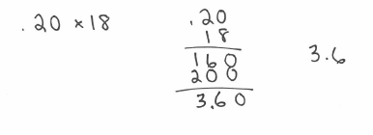
Example: $20\% of 18$

You try: $45\% of 50$ $5\% of 48$ $102\% of 72$

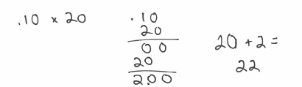
Percent more or less than a number: Find the percent OF the number first, then add or subtract that number to/from the original number
Example: $10\% more than 20$

You try: $40\% less than 60$ $75\% more than 18$ $Cost \$84, but 20\% off$

