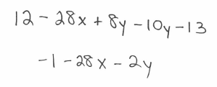
Combining like terms: Do any math first (distributive property, for example). Find like terms, and add/subtract them. Remember that $4x+3x=7x$ and not $7x^{2}$. When you combine like terms, the variables remain the same.
Example: $12-4\left(7x-2y\right)-10y-13$

You try: $6x+6-3\left(4x+6\right)+10$ $y-18x+9+4\left(2y\right)+2(3x-5y)$

Solving equations: Ultimately, get the variable on the side by itself. You may have to move common terms to the same side, combine like terms, get common denominators, etc in order to do this.
Note: When solving an equation involving a lot of fractions, get common denominators first. Then solve the equation using only the numerators (drop the denominators).
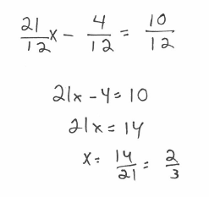
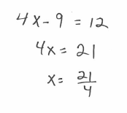
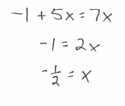
Examples: $7+5x-8=7x$ $\frac{4x-9}{2}=6$ $\frac{7}{4}x-\frac{1}{3}=\frac{5}{6}$

You try: $7x-2=14x-7$ $\frac{2}{3}x+5=9$ $5\left(2x-8\right)+22=12-2x$

$\frac{1}{4}\left(8x+20\right)=3-6x+11$ $\frac{1}{2}x+\frac{2}{3}=\frac{7}{3}$ $\frac{4}{5}+\frac{1}{6}x=\frac{11}{15}$

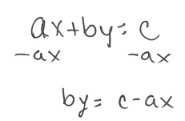
Solving literal equations: Move everything away from the variable you are trying to solve for
Example: Solve for $b$. $ax+by=c$
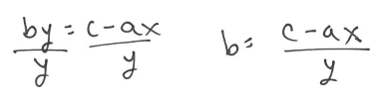

You try: In each, solve for $a$.
$\frac{a}{b}+c=d$ $\frac{ab}{c}=d$ $c\left(a+b\right)=d$

Writing equations from a sentence:
Key words: Sum(addition), Difference(subtraction), Product(multiplication), Quotient(division)
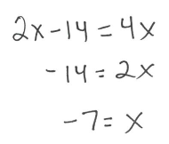
Example: Twice the difference of a number and 7 is the same as the product of 4 and that number.
$2\left(x-7\right)=4x$

You try:
4 more than the quotient of a number and 5 is equal to 12.

The difference between 3 times a number and 1 is the same as the sum of the number and 7.

4 times the sum of a number and 8 is the same as the product of 6 and the number.

Solving equations with word problems: Draw the picture, label the sides, then use the picture to help you write the equation to solve. Recall: perimeter is the sum of all sides of a figure.

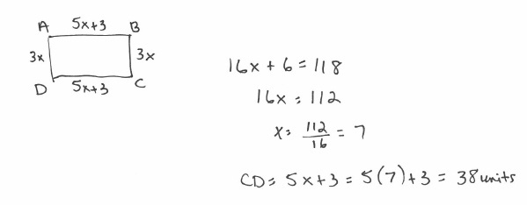
Example: Given a rectangle ABCD, the length of AB is $5x+3$ units, and the length of BC is $3x$ units. Find the length of CD if the perimeter of the rectangle is 118 units.

You try:
Given a square ABCD with a side length of $x+2$ units, find the length of CD if the perimeter of the square is 44 units.

Given a scalene triangle ABC (meaning all sides are a different length), the length of AB is $4x+1$ units, the length of BC is $3x$ units, and the length of AC is $2x-5$ units. Find the length of AB if the perimeter of the triangle is 50 units.

Given a rectangle ABCD, the length of AB is $7x-2$ units, and the length of BC is $10-3x$ units. Find the length of AD if the perimeter of the rectangle is 32 units.

