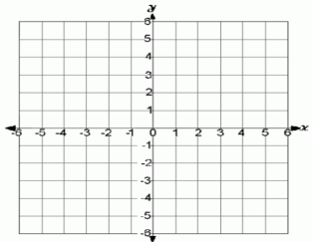
Graphing ordered pairs: To graph a point, move along the x-axis first, and then along the y-axis $(x,y)$.
Ex. Graph $(-3,-1)$ Move to the left 3, then down 1.

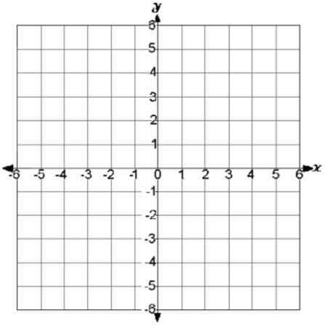
You try: Graph the following on the axis provided:
$$A\left(-2,2\right)$$
$$B\left(5,-4\right)$$
$$C\left(0,3\right)$$
$$D(1,0)$$

Graphing a line:
- Slope-intercept form $y=mx+b$ m stands for the slope, and b is the y-intercept
First mark the y-intercept on the y-axis. Then move from that point with the slope $\left(\frac{rise}{run}\right)$
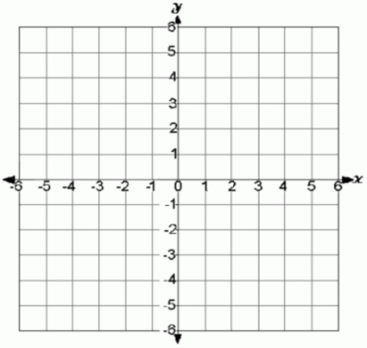
Move up or down first (down if the slope is negative), and then move to the right

Ex. $y=-\frac{2}{3}x+1$ Start at 1 on the y-axis, then down 2, to the right 3
Connect the 2 points with a line.

You try:
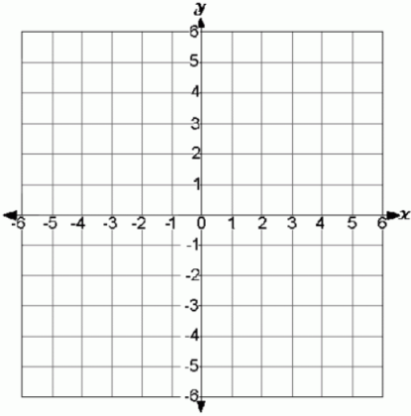
$y=\frac{3}{4}x-3$ $y=-2x+4$ $y=-2$ What about $x=-2$?

Standard form $ax+by=c$ Ex: $3x+2y=6$
Option 1: Change into slope-intercept for to graph
$2y=-3x+6$ $y=-\frac{3}{2}x+3$

Option 2: Find the x and y intercepts and graph those points.
x-intercept ($y=0)$
$3x+2\left(0\right)=6$ $3x=6$ $x=2$ Graph $(2,0)$

y-intercept ($x=0)$
$3\left(0\right)+2y=6$ $2y=6$ $y=3$ Graph $(0,3)$

You try, using either method:
$3x+y=-3$ $x+2y=2$ $2x-5y=10$

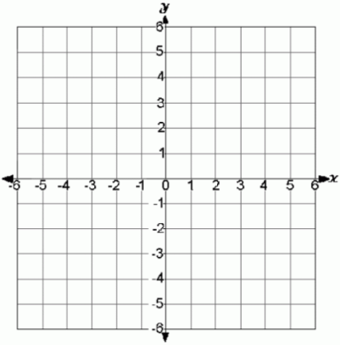

Find the slope (m):
From a graph, choose 2 points, then From 2 ordered pairs, use $\frac{y_{2}-y_{1}}{x_{2}-x_{1}}$
figure out the $\frac{rise}{run}$ $\left(7,1\right) and \left(1,-3\right)$
$\frac{2}{1}=2$, but since $\frac{-3-1}{1-7}=\frac{-4}{-6}=\frac{2}{3}$
the line heads $m=\frac{2}{3}$
downhill, it’s a
negative slope,
So $m=-2$
You try: Find the slope (m).
$\left(12,-2\right) and (4,2)$ $\left(-1,3\right) and (1,8)$

Write an equation in slope-intercept form: Once you have m and b, write the equation $y=mx+b$
Given the slope and an ordered pair Given 2 ordered pairs
Ex. $m=\frac{1}{4} and (-8,3)$ Ex. $\left(6,6\right) and (4,-2)$
Use the ordered pair to find b Find m first.
$3=\frac{1}{4}\left(-8\right)+b$ $3=-2+b$ $b=5$ $m=\frac{y_{2}-y_{1}}{x_{2}-x_{1}}=\frac{-2-6}{4-6}=\frac{-8}{-2}=4$
Equation: $y=\frac{1}{4}x+5$ Choose one ordered pair to find b
$-2=4\left(4\right)+b$ $-2=16+b$ $b=-18$
Equation: $y=4x-18$

You try:
$m=3 and (2,5)$ $m=-\frac{3}{4} and (-4,1)$

$\left(3,5\right) and (5,3)$ $\left(-3,7\right) and (-6,5)$

