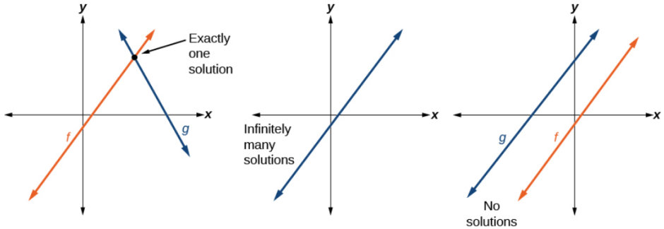
Solving a system of equations by graphing: Graph both lines, and the intersection is the solution.
Possible solutions:

Cross at one point Exact same line twice Parallel lines so never cross
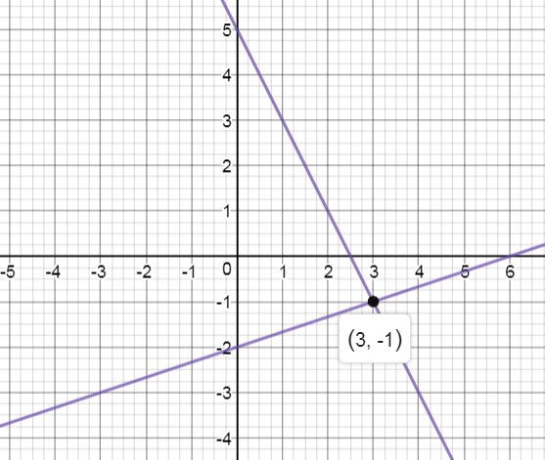
Ex. $y=\frac{1}{3}x-2$
$2x+y=5$ $→$ $y=-2x+5$

Answer: $(3,-1)$

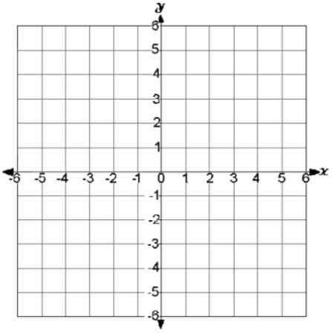
You try:
$y=-\frac{1}{2}x+3$ $4x+3y=6$
$y=4x-6$ $y=-\frac{4}{3}x-1$

Solve the system using Substitution: Take one equation that is solved for x or y and place it in the other equation for that variable.
$$3x+2\left(4x+7\right)=-8$$
$$3x+8x+14=-8$$
$$11x=-22$$
$$x=-2$$
Ex. $y=4x+7$
$$y=4x+7$$
$$y=4\left(-2\right)+7$$
$$y=-8+7=-1$$
Solution: $(-2,-1)$
$3x+2y=-8$

You try:
$3x-y=6$ $5x+y=-8$
$x=y-4$ $y=4-2x$

Solving the system using Elimination: Using multiplication, get the x or y values to equal the opposite numbers (like +6 and -6). Then add the equations together to eliminate one variable.
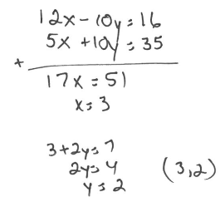
Ex. Method 1: Make x’s the same Method 2: Make the y’s the same
$$6x-5y=8$$
$$x+2y=7$$

You try:
$x+3y=11$ $8x-3y=2$
$4x+5y=9$ $3x+7y=17$

*You can still get infinite or no solutions using Substitution or Elimination.
$10x-2y=6$ $x+4y=12$
$y=5x-3$ $2x+8y=6$

