Graphing inequalities on a number line: Solve for the variable first, then graph.
If $>$ or $<$, use an open circle, and if $≥$ or $≤$, use a closed (filled-in) circle
If $>$ or $≥$, shade to the right, and if $<$ or $≤$, shade to the left
If you multiply or divide by a negative when solving, you must flip the inequality sign
With compound inequalities (2 inequalities on one number line):
AND problems want where BOTH inequalities are true, so shade the overlap
OR problems want all possible solutions, so shade all options
Rules:

Ex. $-4x-3<5$
$-4x<8$ $→$ $x>-2$

$5x+1<-9 or -2x≤-2$ $5x<-10$ $→$ $x<-2$ $or$ $x≥1$

$x-4≥-9 and x-4<-1$ This could also be written this way: $-1>x-4≥-9$
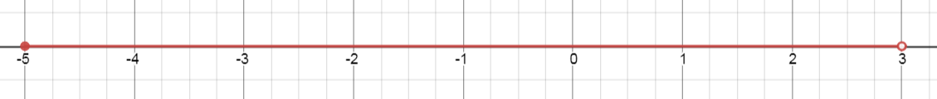
$x≥-5 and x<3$

You try:
$3x>-3 and -4x+9>1$ $-x<-4 or x+9≤5$

$$-1<x+2≤1$$
Graphing an inequality: Graph the line, then shade
Rules:
If $>$ or $<$, use a dashed line, and if $≥$ or $≤$, use a solid line
If $>$ or $≥$, shade above the line, and if $<$ or $≤$, shade below the line

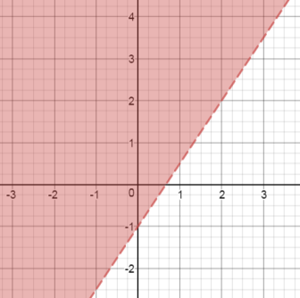
Ex. $3x-2y<2$
$$-2y<-3x+2$$
$$y>\frac{3}{2}x-1$$

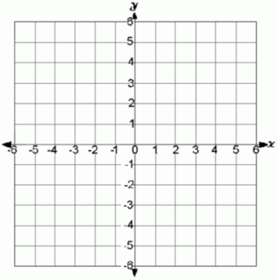
You try:
$4x+y≥3$ $x-3y>12$

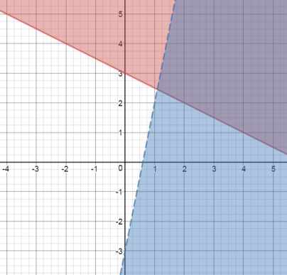
Graphing a system of inequalities: The solution is where the graph is double shaded.
Ex. $x+2y≥6$ $→$
$$2y≥-1x+6$$
$$y≥-\frac{1}{2}x+3$$
$y<5x-3$
Solution

You try:
$5x+y<2$ $3x+2y≥6$
$y≤\frac{3}{2}x$ $x+4y<4$

