ALEKS Pre-Test ANSWERS
Section 1:
- $16$
- $-11$
- $48$
- $-3$
- $545$
- $85$
- $7084$
- $12 r3$
- $35$
- $11$
- $6$
- $1.367$
- $1.47$
- $20.516$
- $12.5$

Section 2:
- $\frac{1}{3}$
- $\frac{26}{35}$
- $\frac{4}{27}$
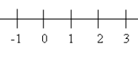
- $\frac{10}{11}$

- $\frac{17}{3}$
- $-2\frac{1}{5}$
- $>$
- $x=\frac{33}{10} or 3\frac{3}{10}$
- $x=\frac{25}{2} or 12\frac{1}{2}$
- $x=\frac{31}{8} or 3\frac{7}{8}$

Section 3:
- $56\%$
- $\frac{7}{25}$
- $17$
- $\$18$

Section 4:
- $25x^{2}$
- $8x^{4}$
- $\frac{7x^{3}}{10}$
- $4.3*{10}^{-4}$

Section 5:
- $CD=18 units$
- $A=21 units^{2}$
- $A=20 units^{2}$
- $A=36π units^{2}, C=12π units$
- $V=100 units^{3}, SA=160 units^{2}$
- $V=72π units^{3}, SA=66π units^{2}$
- $40°$
- $140°$
- $75°$
- No

Section 6:
- $-16x+39y$
- $18$
- $x=23$
- $x=\frac{2}{5}$
- $n=-20$
- $a=\frac{c-b}{4}$
- $x>2$

- $x≤7 and x>-5$

- $x=8 and x=-4$

Section 7:
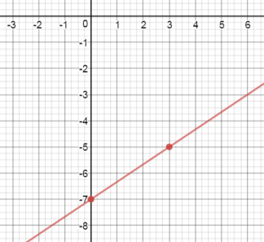
- a. b. Ex. $y=-\frac{3}{2}x+4$

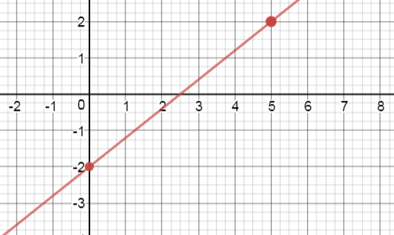

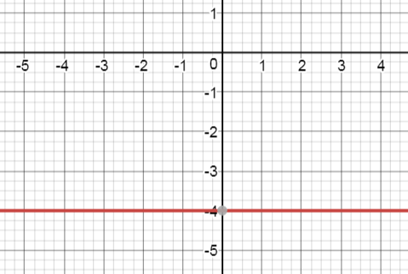

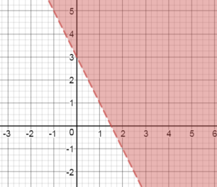

- $y=2x-19$
- $y=-\frac{4}{5}x+3$
- $x int: \left(\frac{3}{2},0\right) y int: \left(0,6\right)$
- $\left(2,10\right)$
- $\left(1,-4\right)$

Section 8:
- $\left\{2,4\right\}$
- $-21$
- Yes
- $D=\left(-∞,∞\right)$ $R=\left[1,∞) \right.$

Section 9:
- $3\sqrt{6}$
- $x=\sqrt{57}$
- $d=\sqrt{85}$

Section 10:
- $12x^{2}-28x+15$
- $x^{2}-8x+16$
- $\left(x-9\right)\left(x+6\right)$
- $\left(x+2\right)\left(3x+5\right)$
- $\left(x+3\right)\left(x-3\right)$
- $x=\frac{-9±\sqrt{57}}{4}$
